[1]

Team Description Paper: Team Emerotecos

Felipe Nascimento Martins, André Seidel Oliveira, Gabriel Lima Guimarães, Ivan Seidel Gomes, Matheus Pimentel Canejo Pinheiro da Cunha

*Resume*— This papper demonstrates the technics used by our team to build and program a robot to join the Robocup Rescue B Challenge.

# Introduction

This is to show team Emerotecos’ strategies to solve the challenge proposed to the Rescue B Competition.

To build the robot, we didn’t use any building kit, as we designed the whole robot from sketch, using Dassault Systemes’ Solid Works. The robot was built basically with 5mm thick acrylic pieces, whose are tough enough for the application.

As the main processor, we use an Android phone, which is programmed using java.

To send the signals from the android to the motors (whose are controlled by an MBED board), we use a board called IOIO, which is responsible for reading all the sensors as well.

# Objective

The objective of this project is to build a smart robot that can cross a maze build with wood walls, and identify the electrically heated victms that are placed along the maze’s walls.

# Ambient

The Challenge happens in a modular arena, made with wood, wich has 2 floors, and 4 main rooms. The location of the walls are always unknown by the time the robot starts running, so that it runs in a real maze. The only constant information about the arena, is it’s total size, what makes it easier to the robot to find it’s way on the place.

Some heatened “victim” are randomly positioned on some walls in the arena, and the robot has to identify them to get points.

In some places, there are some “dead ends”, which are a black mat on the ground. The robot can run over these black mats, but it has to leave it on the same side it came from, it can’t cross the black área.

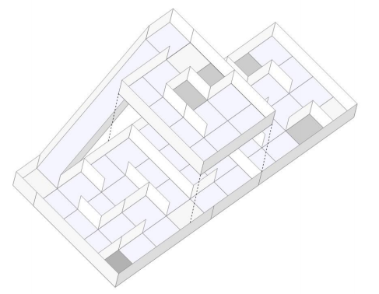

1. 3D Arena

# Strategy

## A. Structure

Our robot is built basically with 2 acrylic layers, and some acrylic beams. We use a Mecanum omnidirectional whells system, which makes our robot able to drive to every direction. The mecanum system works as a regular omni system, but it uses 4 tractioned whells, instead of three, normally used.

We use 4 very strong motors, with encoders, so that we can precisely move our robot everywhere.

To make good measurements with the infrared distance sensors, we’ve put them in a turnable head over the robot, so that we can make meausures to every direction.

To identify the victims, we have 4 thermal infrared sensors startegicaly positioned around the robot, so that we can measure temperatures in every wall.

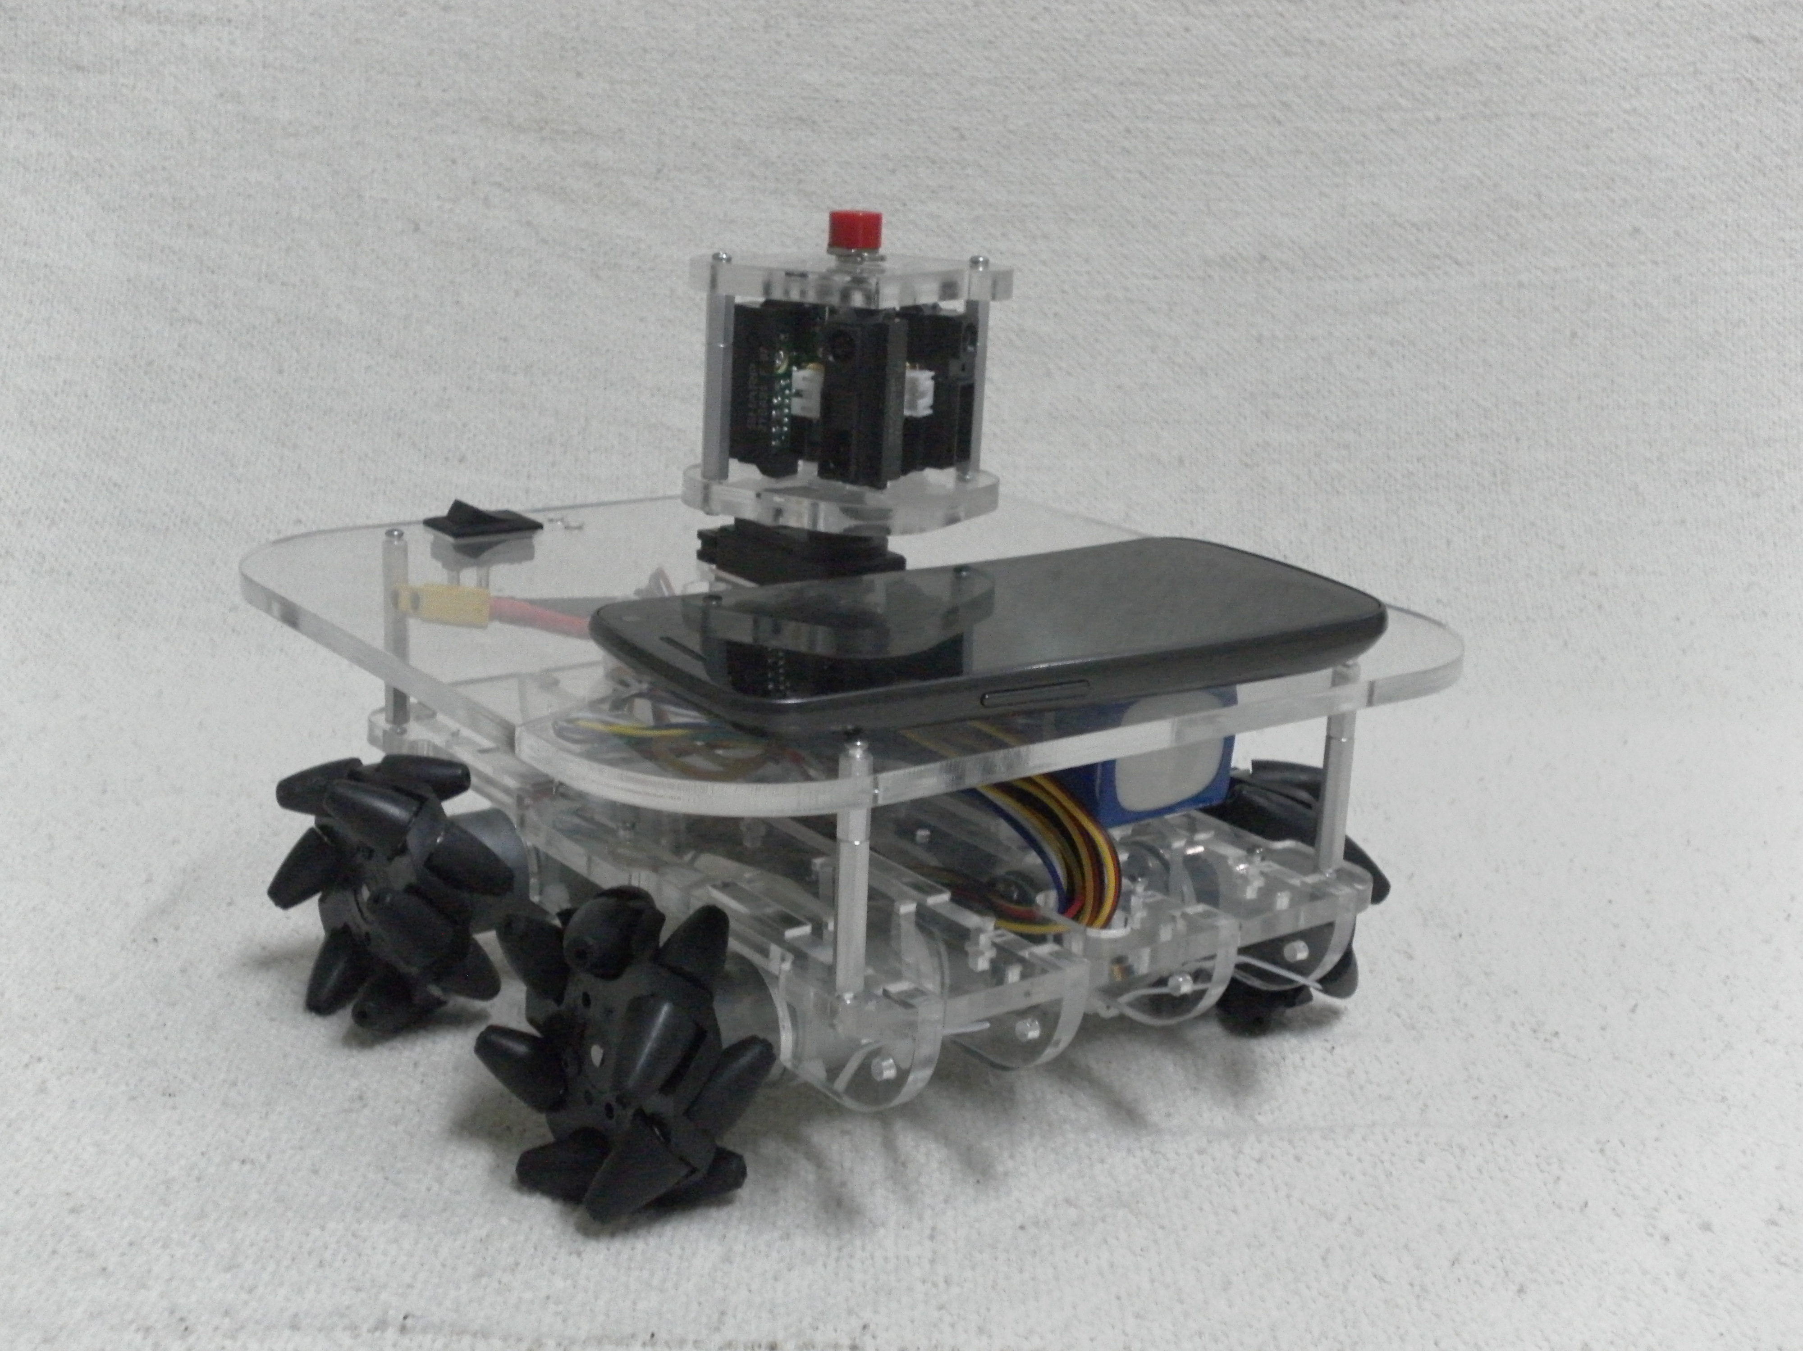

1. Robot picture(without contro boards)

#### As you can see in the image above, the distance sensors are positioned on a servo motor, so that they can be aimed to virtually any direction.

Its visible too how are the mecanum wheels mounted on the robot, similar to a Four by Four car, but with the capacity of moving to any direction without the need to turn.

## B. Programming

## The main controller o four robot, is an Android cellphone. We choose Android, becaus its a very open plataform, and it’s possible to connect the cellphone with the sensors easily, using the IOIO board.

To move the robot, we use a kind of SLAM (Simultaneous Localization And Maping) algorithm, so that we can map the arena. While the robot walks around the arena, we can see the map being formed on the cellphone’s screen. Maping is the best way to solve this challenge, because it’s makes it easy to visit every module of the arena, and consequently, find all victims.

The SLAM was programmed in JAVA, and it runs on the Android. The Android sends and receives data to/from the IOIO, which reads the sensors, and communicates with the MBED board, the one responsible for controlling the motors.

1.